Worksheet 7.3

Ozone layer
Student: Class:

Ozone and altitude
1. The following graph shows the ozone level (measured as the pressure of ozone in millipascals) as a function of altitude. Answer the questions about this graph.
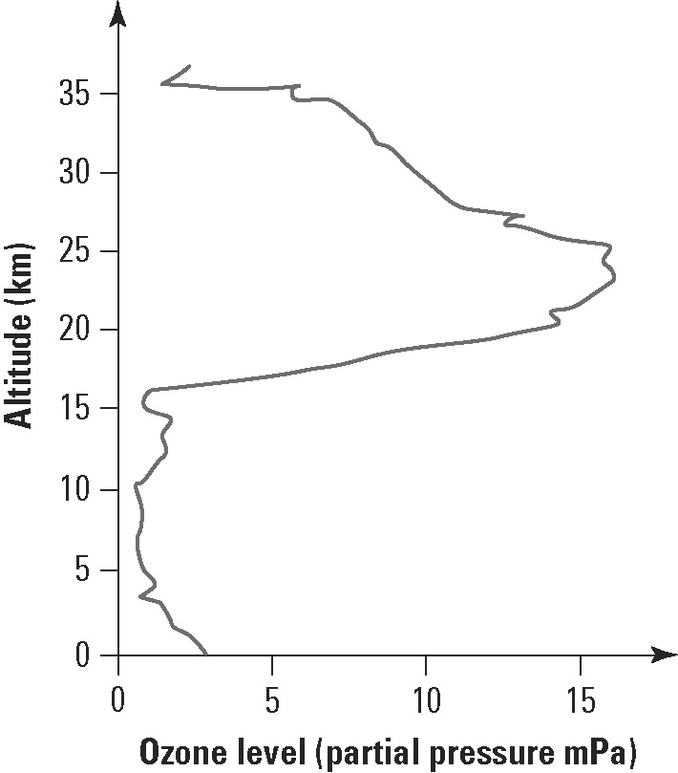 | (a) What is the ozone level at sea level?  (b) At what altitude is the maximum ozone level?  (c) In what atmospheric layer is the maximum ozone level located?  (d) Calculate the ratio of the maximum ozone level in the stratosphere to the maximum ozone level in the troposphere.

Ozone depletion
2. The following graph shows changes in the area of the ozone hole in the stratosphere above Halley Bay, Antarctica, for the same four-month period over three different years. The ozone hole is a region of the stratosphere that has severely depleted levels of ozone. Answer the questions about this graph.
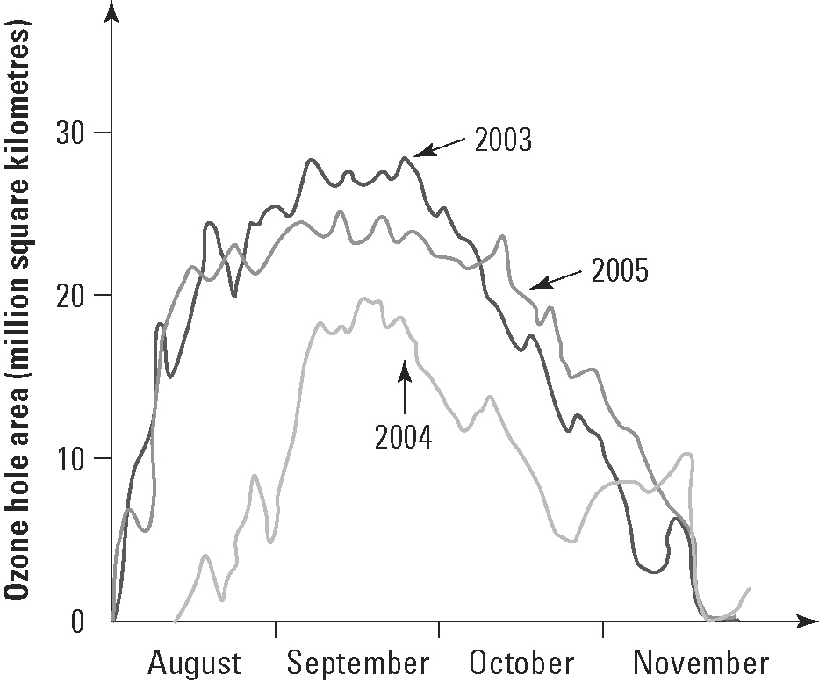 | (a) In which season of the year do the largest ozone holes appear over Antarctica?  (b) Compare the area of the ozone holes over these three years.  (c) Determine the size of the ozone hole at the end of September in 2004.  (d) Studies in Chile showed a significant increase in skin cancers since ozone holes first started to appear in the mid-1980s. Explain why this would happen.

